EXPERIMENT-03 DHILIPAN M
14/07/2026 192411038

WATER JUG PROBLEM USING BREADTH-FIRST SEARCH (BFS) ALGORITHM

AIM:
To write a Python program to solve the Water Jug Problem using the Breadth-First Search (BFS) algorithm.

ALGORITHM:
Step 1: Read the capacities of the two water jugs and the target amount from the user.
Step 2: Initialize the starting state with both jugs empty.
Step 3: Generate all possible valid states by filling, emptying, or pouring water between the jugs.
Step 4: Apply Breadth-First Search (BFS) to explore all possible states.
Step 5: Check whether the target amount is obtained in either of the jugs.
Step 6: Display the sequence of states if the target is reached; otherwise, display "No Solution Found."

PROGRAM:
from collections import deque
a=int(input("Enter capacity of Jug 1: "))
b=int(input("Enter capacity of Jug 2: "))
target=int(input("Enter target amount: "))
queue=deque([((0,0),[(0,0)])])
visited=set()
while queue:
(x,y),path=queue.popleft()
if x==target or y==target:
print("Solution Found")
for state in path:
print(state)
break
if (x,y) in visited:
continue
visited.add((x,y))
states=[
(a,y),
(x,b),
(0,y),
(x,0),
(max(0,x-(b-y)),min(b,x+y)),
(min(a,x+y),max(0,y-(a-x)))
]
for state in states:
if state not in visited:
queue.append((state,path+[state]))
else:
print("No Solution Found")

OUTPUT:

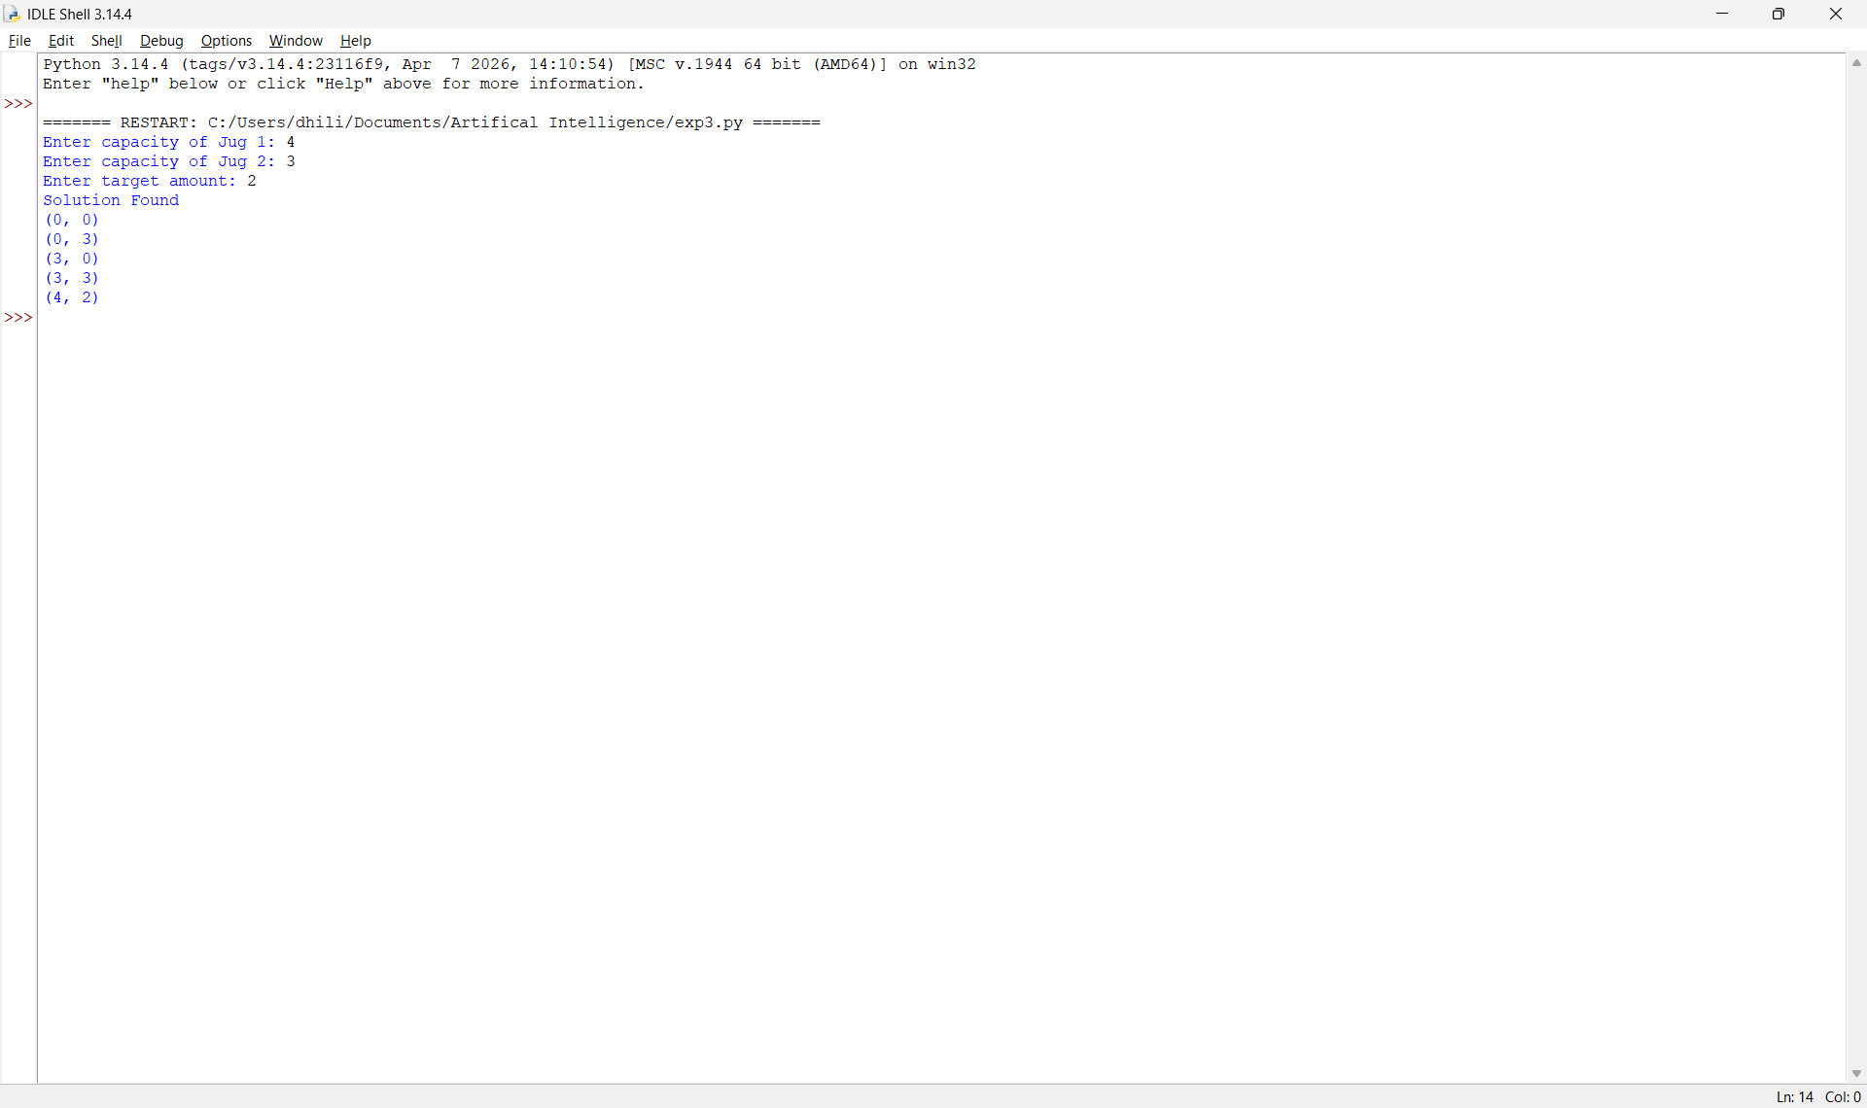

RESULT:
Thus, the Python program to solve the Water Jug Problem using the Breadth-First Search (BFS) Algorithm was implemented successfully and the required output was obtained.

